1. **A measure of central tendency** 
   1. **Mean**
   2. **Median**
   3. **Mode**

**A measure of central tendency:**

There are three main measures of central tendency: the mode, the median, and the mean. Each of these measures describes a different indication of the typical or **central value** in the distribution.

**Mean:** find out the Average of the data

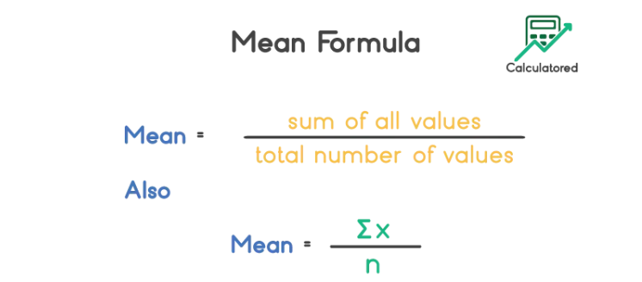

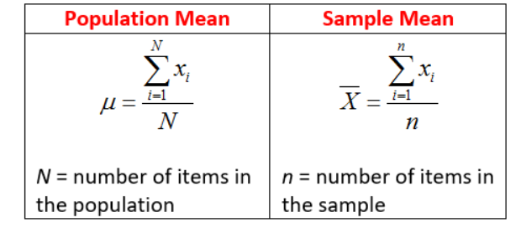

**Median:**

**Median for Even:**

If the Number of elements are even the find the average of the central elements.  
Ex [1,2,3,4,**5,6**,8,100,120]

Median for Even   
=5+6/2  
=11/2  
=5.6

**Median for Odd**:

If the Number of elements are odd then find the average of the central element.  
Ex [1,2,3,4**,5,**6,8,9,100,120]

We can directly take the central element as the final value for the Median which is 5 in this case.

**Mode:**

Mode is the most frequently occurring element.

Example1:   
{2,2,2,3,4,4,5,5,5}  
2 and 5 is a mode for the above case  
Example1:   
{2,2,2,3,4,4,5,5,7,8,8}   
2 is the mode in this case since 2 is occurring most of the time.